ASSIGNMENT WORD DELIVERABLE 2021

Student Name

Institution

Course Name/Number

Due Date

Instructor Name

# THINGSPEAK CHANNEL CONFIGURATION

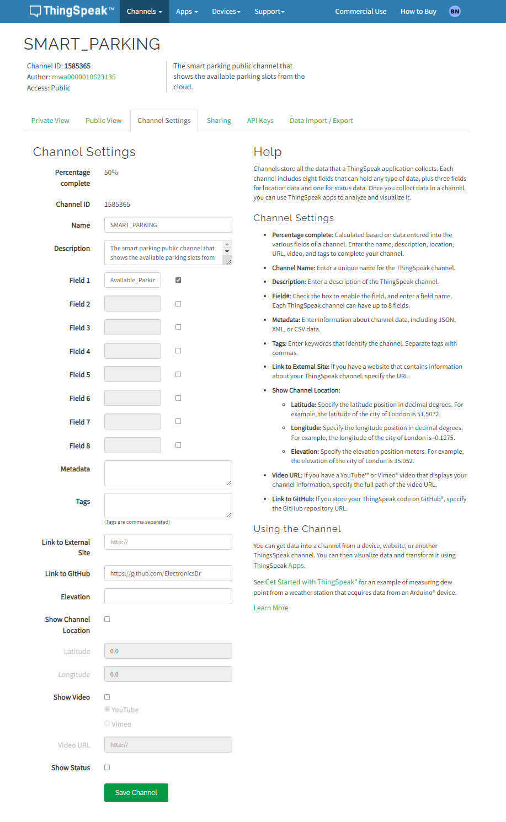

*Figure showing the Thingspeak Configuration for the data fields.*

# ARDUINO CODE

This code goes into the target Arduino code to allow the microcontroller to communicate with the server otherwise without it the data won’t be reflected from the physical layer to the network layer. This sketch uses ESP8266 Wi-Fi Module connected to the Arduino using the TX and RX pins and the internet using the set WI-FI SSID and password.

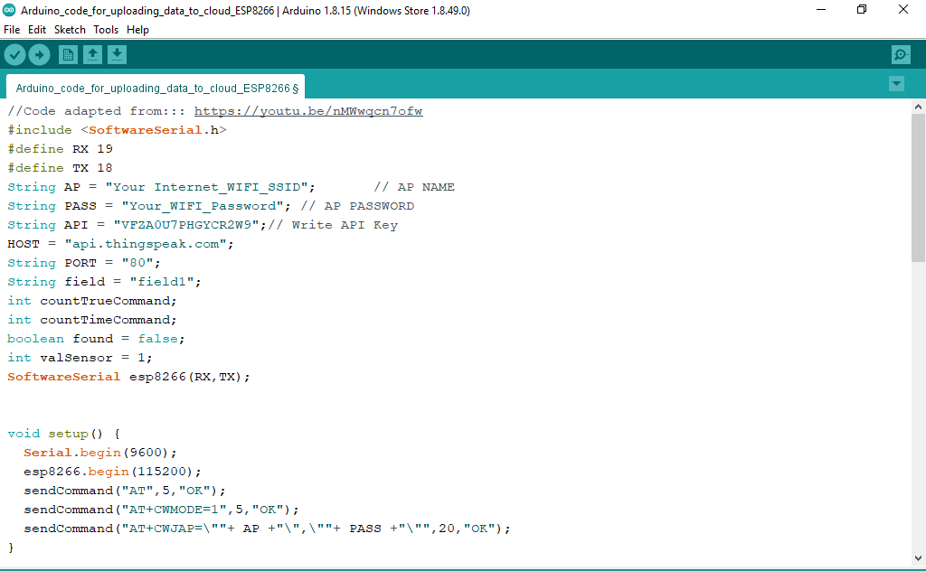

*Figure showing the ESP8266 Wi-Fi Module with Arduino (part 1).*

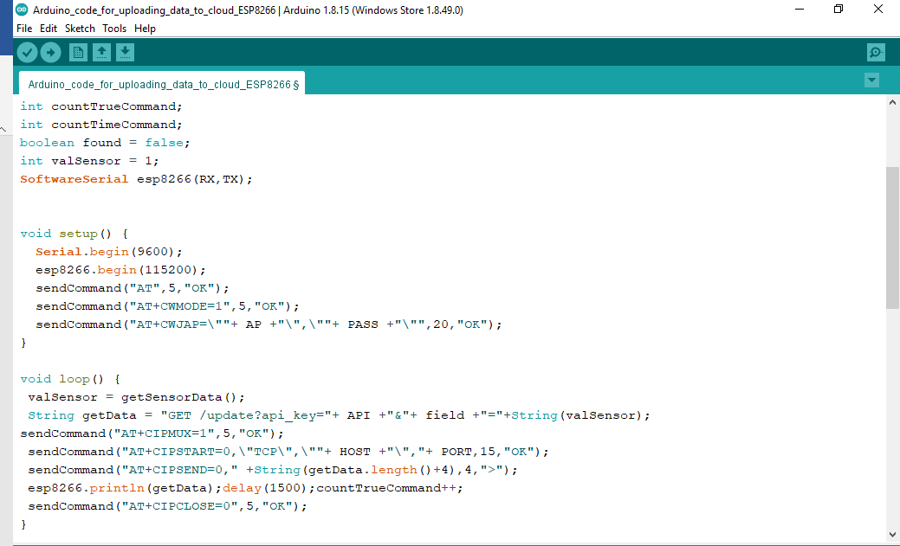

*Figure showing the ESP8266 Wi-Fi Module with Arduino (part 2).*

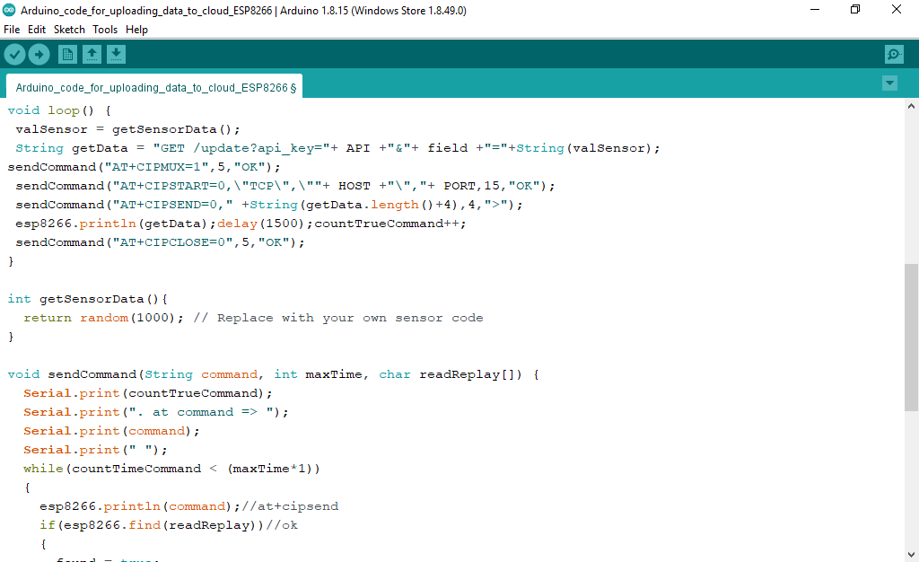

*Figure showing the ESP8266 Wi-Fi Module with Arduino (part 3).*

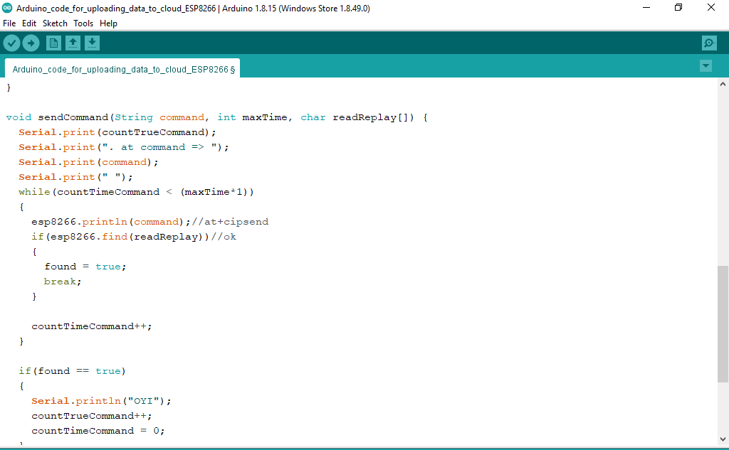

*Figure showing the ESP8266 Wi-Fi Module with Arduino (part 4).*

# MATLAB APP DESIGNER

MATLAB App Designer is the GUI application in the software that allows introduction of buttons and lamps indicating the status of the parking slots.

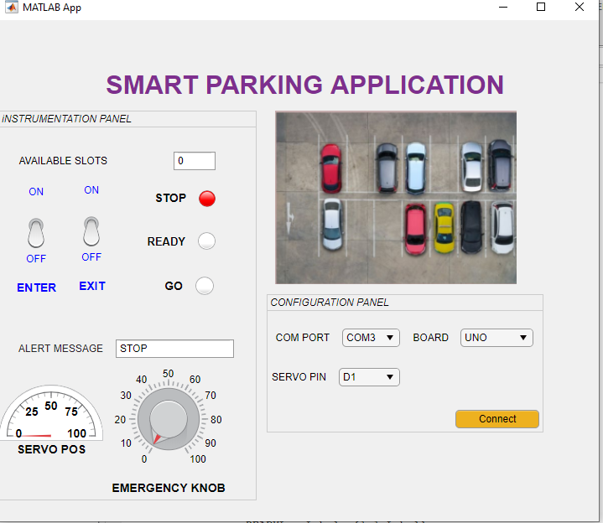

*This is the MATLAB GUI that controls the smart parking either automatically or manually for the emergency situation.*

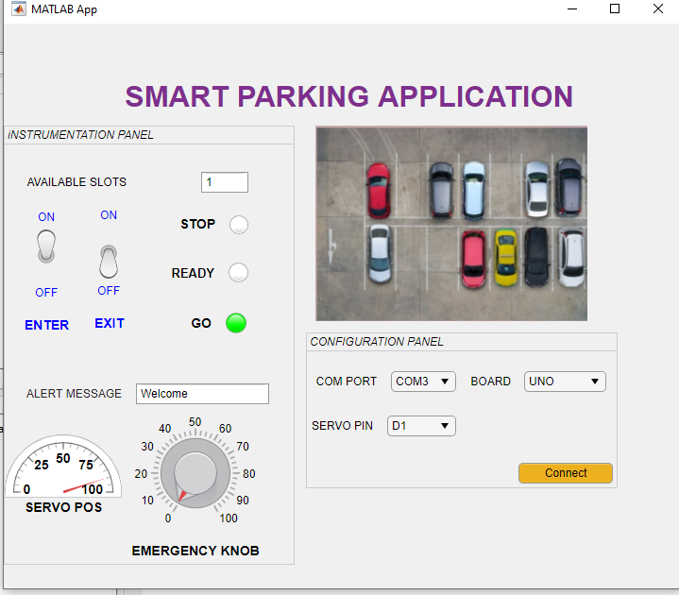

*Figure shows the available slots changing values with the servo position moving to 90 degrees with the alert message informing the driver “Welcome”.*

# MATLAB APP DESIGNER CODE

This the code controlling the GUI buttons and figures in the smart parking system.

methods (Access = private)

% Code that executes after component creation

function startupFcn(app)

% Arduino connection

port=string(app.COMPORTDropDown.Value);

com_port=lower(port);

board=string(app.BOARDDropDown.Value);

arduino_board=lower(board);

if board=='mega2560'

board=[upper(board(1)),lower(board(2:lastIndex))];

return

end

servo_pin=string(app.SERVOPINDropDown.Value);

function connectButtonPushed(~)

arduino_target=arduino(com_port,arduino_board);

servo_motor=servo(arduino_target,servo_pin);

writePosition(servo_motor,1);

end

global parking_count

parking_count=14;

app.STOPLamp.Color=[1.00,0.00,0.00];

app.ALERTMESSAGEEditField.Value="STOP";

value1 = app.ENTERSwitch.Value;

value2 = app.EXITSwitch.Value;

for parking_count=0:14

switch value1

case 'ON'

app.SERVOPOSGauge.Value=90;

%app.AVAILABLESLOTSEditField.Enable='on';

app.ALERTMESSAGEEditField.Enable='on';

app.STOPLamp.Color=[1.00,1.00,1.00];

app.ALERTMESSAGEEditField.Value='Welcome';

app.GOLamp.Color=[0.00,1.00,0.00];

parking_count=parking_count+1;

app.AVAILABLESLOTSEditField.Value=int2str(parking_count)

break;

case 'OFF'

parking_count=parking_count;

app.AVAILABLESLOTSEditField.Value=int2str(parking_count);

app.STOPLamp.Color=[1.00,0.00,0.00];

app.GOLamp.Color=[1.00,1.00,1.00];

app.READYLamp.Color=[1.00,1.00,1.00];

app.SERVOPOSGauge.Value=0;

break;

otherwise

app.GOLamp.Color=[1.00,1.00,1.00];

app.READYLamp.Color=[1.00,1.00,1.00];

app.STOPLamp.Color=[1.00,1.00,1.00];

app.SERVOPOSGauge.Value=0;

end

% Exit Toggle switch callback

switch value2

case 'ON'

app.SERVOPOSGauge.Value=90;

%app.AVAILABLESLOTSEditField.Enable='on';

app.ALERTMESSAGEEditField.Enable='on';

app.STOPLamp.Color=[1.00,1.00,1.00];

app.ALERTMESSAGEEditField.Value='Goodbye';

app.GOLamp.Color=[0.00,1.00,0.00];

parking_count=parking_count-1;

app.AVAILABLESLOTSEditField.Value=int2str(parking_count);

break;

case 'OFF'

parking_count=parking_count;

app.AVAILABLESLOTSEditField.Value=int2str(parking_count);

app.STOPLamp.Color=[1.00,0.00,0.00];

app.GOLamp.Color=[1.00,1.00,1.00];

app.READYLamp.Color=[1.00,1.00,1.00];

app.SERVOPOSGauge.Value=0;

break;

otherwise

app.GOLamp.Color=[1.00,1.00,1.00];

app.READYLamp.Color=[1.00,1.00,1.00];

app.STOPLamp.Color=[1.00,1.00,1.00];

app.SERVOPOSGauge.Value=0;

end

break;

end

end

# ARDUINO AND THINGSPEAK API KEY CONFIGURATION

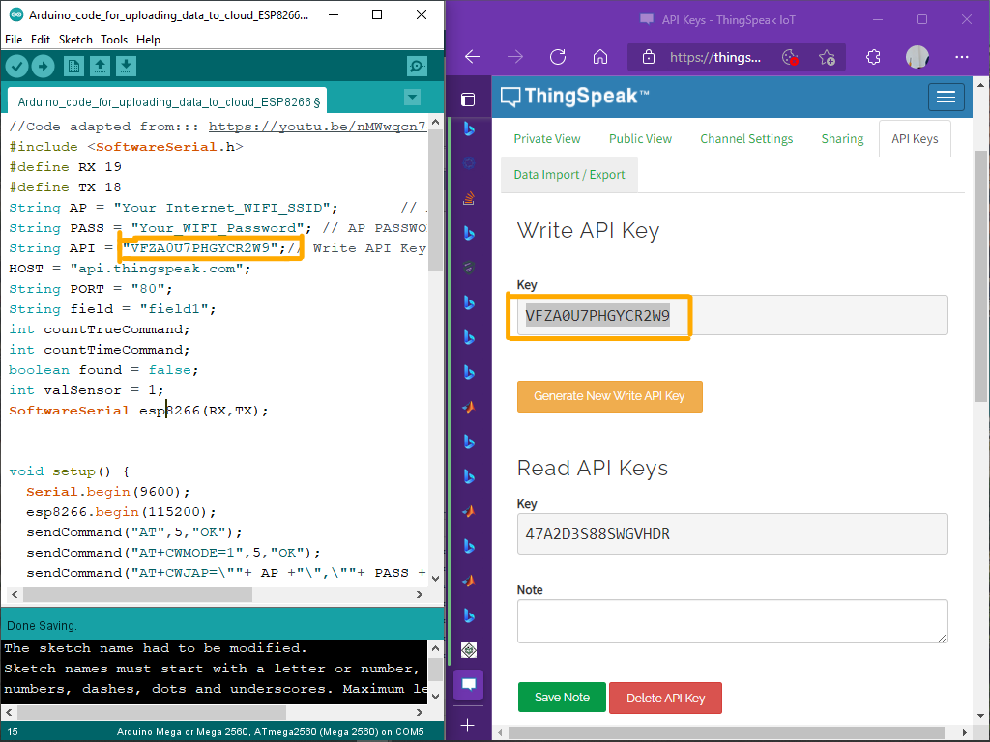

*Figure showing the Thingspeak API Key Configuration in Arduino and Thingspeak site.*

# MATLAB VISUALIZATION

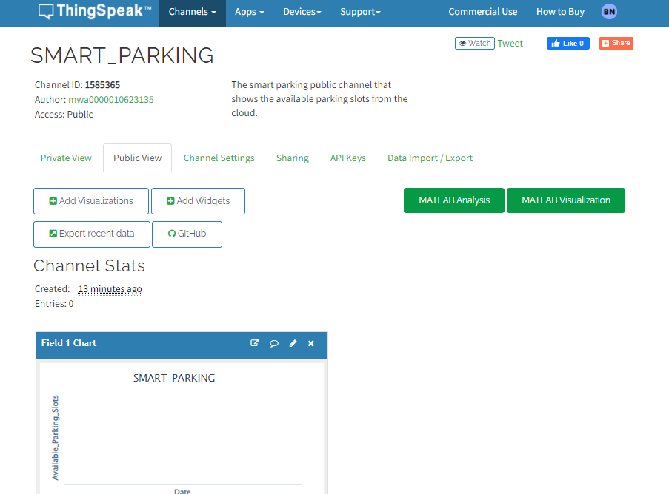

*Figure showing the visualization for the available slots (“Note this is currently empty since there was no present connection with the Arduino board which is to come later”)*

# **APPENDIX 2: MATLAB APP DESIGNER CODE**

app.AVAILABLESLOTSEditField.Value=int2str(parking_count);

app.STOPLamp.Color=[1.00,0.00,0.00];

app.ALERTMESSAGEEditField.Value="STOP";

value1 = app.ENTERSwitch.Value;

value2 = app.EXITSwitch.Value;

if(strcmpi(value1,'ON'))

app.SERVOPOSGauge.Value=90;

parking_count=parking_count-1;

app.AVAILABLESLOTSEditField.Enable='on';

app.AVAILABLESLOTSEditField.Value=int2str(parking_count);

app.ALERTMESSAGEEditField.Enable='on';

app.STOPLamp.Color=[1.00,1.00,1.00];

app.ALERTMESSAGEEditField.Value='Welcome';

app.GOLamp.Color=[0.00,1.00,0.00];

elseif((strcmpi(value1,'OFF')))

parking_count=parking_count;

app.AVAILABLESLOTSEditField.Value=int2str(parking_count);

app.STOPLamp.Color=[1.00,0.00,0.00];

app.GOLamp.Color=[1.00,1.00,1.00];

app.READYLamp.Color=[1.00,1.00,1.00];

app.SERVOPOSGauge.Value=0;

else

app.GOLamp.Color=[1.00,1.00,1.00];

app.READYLamp.Color=[1.00,1.00,1.00];

app.STOPLamp.Color=[1.00,1.00,1.00];

app.SERVOPOSGauge.Value=0;

end

% Exit Toggle switch callback

if(strcmpi(value2,'ON'))

parking_count=parking_count+1;

app.AVAILABLESLOTSEditField.Enable='on';

app.AVAILABLESLOTSEditField.Value=int2str(parking_count);

app.ALERTMESSAGEEditField.Enable='on';

app.ALERTMESSAGEEditField.Value='Goodbye';

app.STOPLamp.Color=[1.00,1.00,1.00];

app.GOLamp.Color=[0.00,1.00,0.00];

app.SERVOPOSGauge.Value=100;

elseif((strcmpi(value2,'OFF')))

parking_count=parking_count;

app.AVAILABLESLOTSEditField.Value=int2str(parking_count);

app.STOPLamp.Color=[1.00,0.00,0.00];

app.GOLamp.Color=[1.00,1.00,1.00];

app.READYLamp.Color=[1.00,1.00,1.00];

app.SERVOPOSGauge.Value=0;

else

app.GOLamp.Color=[1.00,1.00,1.00];

app.READYLamp.Color=[1.00,1.00,1.00];

app.STOPLamp.Color=[1.00,1.00,1.00];

app.SERVOPOSGauge.Value=0;

end

**REFERENCES**

Amrani, D., & Paradis, P. (2010). Use of computer-based data acquisition to teach physics laboratories: case study-simple harmonic motion. *Latin-American Journal of Physics Education*, *4*(3), 6.